FINANCIAL RESULTS
Q1 2023

Press Contact:

INA, d.d.
Corporate Communications and Marketing
Avenija Većeslava Holjevca 10, Zagreb

E-mail: pr@ina.hr
Press Centre at www.ina.hr

Stable result with negative impact of regulatory constraints

- In terms of external environment, beginning of 2023 was marked by oil and gas prices stabilization and continuation of regulatory constraints, which had a negative impact on Q1 2023 result.

- Natural decline of production is at very favourable 2%, a strong result taking into consideration maturity of INA’s Exploration and Production portfolio.

- Offshore gas production increased 13%, as a result of the drilling campaign.

- Large investment cycle continues, including the execution of Rijeka Refinery Upgrade Project, which reached 74% completion in Q1 2023.

- Financial position remains robust with gearing below 10%.

Key figures:
- Net sales revenues amounted to EUR 760.8 mln
- CCS EBITDA amounted to EUR 23.2 mln
- CAPEX amounted to EUR 53 mln

Zagreb, 27 April 2023 – In terms of external environment beginning of 2023 was marked by prices stabilization and continuation of regulatory constraints. INA Group CCS EBITDA excl. special items in Q1 2023 amounted to EUR 23 million, stark contrast compared to Q1 2022 figure of EUR 130 million. On top of negative regulatory impact, this change is related primarily to stabilisation of price environment in Q1 2023.
EBITDA of Exploration and Production amounted to EUR 98 million, with result being combination of stable production and limited gas price for majority of production. Natural decline of production is at very favourable 2%, a strong result taking into consideration maturity of INA’s Exploration and Production portfolio. Offshore gas production increased 13%, following first results of the drilling campaign.
Refining and Marketing incl. Consumer services and Retail segment result remains negatively impacted by fuel price regulation which, combined with the investment activities (mainly the Rijeka Refinery Upgrade Project) and lower realized wholesale margins, resulted in negative cash flow of the segment. Also, Rijeka Refinery production will be started up in Q2 2023. Retail sales grew by 13% and the non-fuel margin growth continued. Large investment cycle continues in 2023 including the execution of Rijeka Refinery Upgrade Project, which reached 74% completion in Q1 2023.
Financial position remains robust with gearing below 10%.

Statement of Péter Ratatics, President of the Management Board of INA:

“After 2022, with its soaring energy prices, 2023 is marked with strong level of market regulation in many countries. Despite the external movements and heavily regulated environment, with sense of obligation we managed to deliver on our main strategic responsibility – to ensure continuous supply of our customers. At the same time, we are continuing with one of the most intensive investment periods at INA. Works on Rijeka Refinery maintenance continue as planned, with production startup during Q2 2023. Safe supply of the market was not endangered in any period, regardless of the refinery operations, but the production startup will further strengthen the supply possibilities.
Rijeka Refinery Upgrade Project achieved 74% completion in overall. Its completion will bring economic sustainability of refining business on the long run to a higher level. When discussing the investments, it should also be mentioned that offshore drilling campaign results are visible in the production, with the 13% increase in offshore gas production.
Exploration and Production continue its trend of moderating the natural production decline. Decrease of overall hydrocarbon production of just 2% is a strong result, taking into consideration the overall age of INA’s production portfolio, with many fields in production around or more than 40 years. With these efforts, security of gas supply is strong while on the other hand, volatility of hydrocarbon prices and regulation in place continue to bring level of uncertainty for future results. Refining and Marketing including Consumer Services and Retail operations are pressured by reduced margins.
As in 2023 hydrocarbon prices stabilized at lower levels, I believe operating on market-based principles in a deregulated pricing environment should be enabled. INA will continue to ensure safe market supply while aiming to provide the shareholders with profitable operations.”

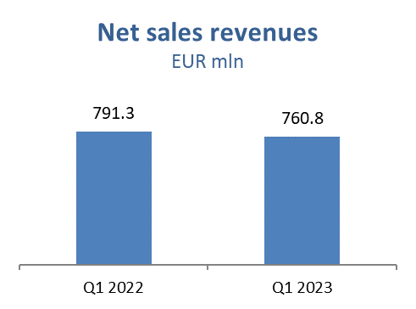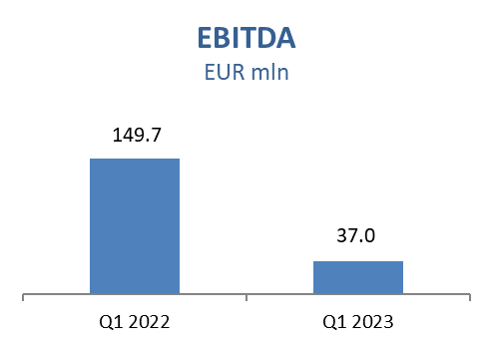
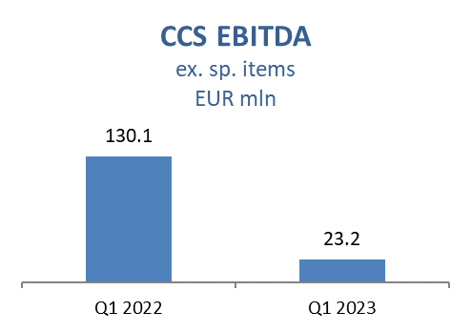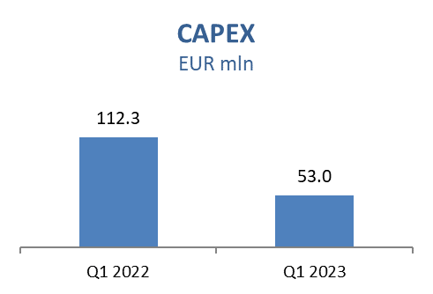

Exploration and Production
Lower prices impacted sales revenues negatively by EUR 18.5 million mainly driven by lower oil price. Production decreased by only 2%, compared to 6% decline 2022 vs. 2021 in same period, which is a strong improvement considering the maturity of INA’s oil and gas fields. Despite better offshore well performance driven by significantly increased production on Ika field after performed workover and higher production on Ivana field after process optimization, Croatian production decreased because of lower onshore contribution due to natural decline and increased water cuts on different fields.

Lower CAPEX level compared to Q1 2022 mainly due to the Croatia offshore drilling campaign being in EPCI (Engineering, Procurement, Construction, Installation) tendering phase in Q1 2023. Main activities during Q1 2023 were related to:

Croatia Exploration:
- Drava-03: Preparatory activities for drilling V. Rastovac-1 ongoing
Croatia Offshore:
- Permitting for drilling exploration well Izabela-9 in progress
Croatia Onshore:
- Production optimization: performed 9 well workovers in Q1 2023
Egypt:
- North Bahariya concession: 5 wells drilled (4 producers and 1 water injector), drilling of 2 wells ongoing
- Ras Qattara: Drilling of 1 development well completed in February. Concession extension procedure ongoing

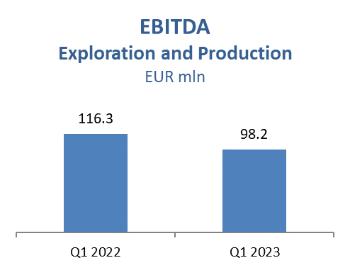
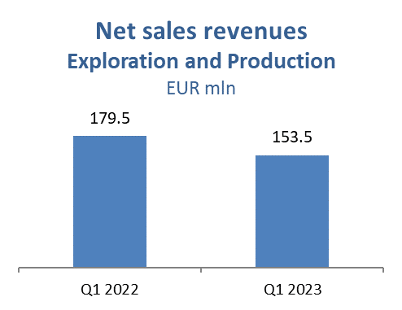

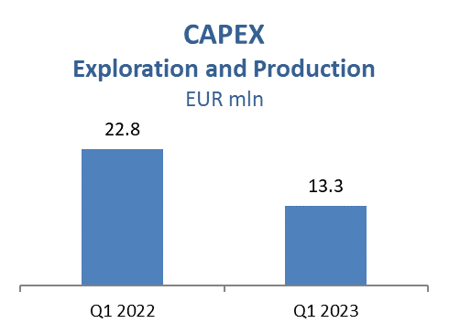

Refining and Marketing, including Consumer Services and Retail
Adverse commercial margins in a decreasing product price environment was a stark contrast compared to the soaring prices in Q1 2022, on the back of the Russia-Ukraine war. Finalisation of investments in brownfield part of Rijeka Refinery Upgrade Project during Q1 2023 required temporary shutdown of refining activities, implying operation in import mode. Trading activities were focused on safe and timely product supply, with higher sales to captive market.

Total Retail sales volumes amounted to 263 kt in Q1 2023 which is 13% above Q1 2022 due to higher realisation on Croatian market (+33.3 kt), mainly as a result of positive market trends and lower fuel price compared to neighbouring countries. Non-fuel margin increased 25% reflecting continuous expansion in consumer goods, increasing number of Fresh Corners and improved sales techniques together with INA Loyalty program support which surpassed 480 thousand registered members.

Refining and Marketing CAPEX amounted to EUR 37 million with Rijeka Refinery Upgrade Project on 74% completion in overall, with the engineering and procurement reached above 99%. Construction is close to 60% with focus on the works during the Rijeka Refinery shutdown period. The first part of the works on CDU (Crude Distillation Unit) Energy Efficiency Upgrade Project are completed during Rijeka Refinery shutdown as planned. Regarding the replacement of condensing turbines with electric drives, detail design is completed and the excavation works on FCC (Fluid Catalytic Cracking) are in progress.

Consumer Services and Retail capital investments amounted to EUR 1.6 million in Q1 2023 with focus on network expansion resulting in 3 new service station openings, with total amount of 507 stations (out of which 390 in Croatia).

