FINANCIAL RESULTS
2022

Press Contact:

INA, d.d.
Corporate Communications and Marketing
Avenija Većeslava Holjevca 10, Zagreb

E-mail: pr@ina.hr
Press Centre at www.ina.hr

Investment activities for 2022 highest in the last ten years

- 2022 was marked by high level of economic uncertainty and large changes on the commodity market caused by war in Ukraine.

- Oil and gas industry throughout the world recorded strong results in such times, but faced a variety of regulatory pressures, ranging from regulated prices in various business areas to extra taxes imposed.

- In such environment, INA Group has achieved a strong result, although various regulatory restrictions had a negative impact throughout the segments. Exploration and Production stayed the biggest cash generator in conditions of high hydrocarbon prices.

- Investment activities for 2022 were highest in the last ten years, with a 71% increase compared to 2021, total of HRK 2.7 billion, out of which 95% invested in Croatia. Rijeka Refinery Upgrade Project and the Offshore drilling campaign remain the biggest investments.

- Natural decline of production is moderated with the increased production optimization activities. Offshore drilling campaign continued throughout the year with results already visible in 6% higher offshore production volumes thanks to two new wells put into production last year.

Key data*:
- Net sales revenues amounted to HRK 35.1 billion (EUR 4.7 bn)
- CCS EBITDA amounted to around HRK 5.5 billion (EUR 0.7 bn)
- CAPEX increased 71% year-on-year, to HRK 2.7 billion (EUR 0.4 bn)

*Note: In accordance with legal regulations, the financial report for 2022 is submitted in HRK, while the reports for the first quarter of 2023 and all future reports will be submitted in EUR (with informative USD figures, standard for oil industry). This is why in this press kit only the key data figures are presented in EUR.
Zagreb, 16 February 2023 – 2022 was marked by high level of economic uncertainty and substantial changes on the commodity market caused by war in Ukraine, that impacted the entire economy. Oil and gas industry throughout the world recorded strong results in such times, but also faced a variety of regulatory pressures, ranging from regulated prices in various business areas to extra taxes imposed.
INA Group CCS EBITDA excl. special items in 2022 amounted to around HRK 5.5 billion with net profit of HRK 1.9 billion. Net profit was impacted by one-off items in the total amount of HRK 789 million.
Refining and Marketing incl. Consumer services and Retail segment result was highly impacted by regulatory limitations which, combined with the intensive investment cycle in the Rijeka Refinery Upgrade Project, resulted in around one billion HRK negative cash flow of the segment.
Exploration and Production returned to the position of the main cash generator, reflecting improved price environment. EBITDA of Exploration and Production amounted to HRK 4.9 billion, limited from Q4 2022 by the regulated gas prices at 41 EUR/MWh, which is to stay in force until Q1 2024. Decline of production is a result of natural decline due to mature fields and is moderated with the increased production optimization activities, amounting to -4% on yearly level. Offshore drilling campaign continued throughout the year with results already visible in 6% higher production volumes offshore thanks to two new wells put into production last year.
2022 was additionally marked by various price and margin regulations impacting operational segments of both results, with newly imposed extra profit tax burdening cash generation.
Investment activities for 2022 were highest in the last ten years, with a 71% increase compared to 2021, total of HRK 2.7 billion, out of which 95% invested in Croatia. Residue Upgrade Project and the Offshore drilling campaign remain the biggest investments. Operating cash flow of the company remains stable on year level, despite the strong investment cycle and working capital needs consumes the improved results from operations.

Statement of Péter Ratatics, President of the Management Board of INA:

“2022 was marked by worldwide energy market turmoil, but also one of the strongest investment periods for INA ever. Despite the huge oscillations on hydrocarbon prices and the regulatory interventions, INA stays committed to the ongoing large investment cycle. Rijeka Refinery Upgrade Project, the biggest investment of INA and the offshore drilling campaign push the investments to the highest level in ten years, with more than HRK 2.7 billion investments in total. Also, it is worth mentioning that Rijeka Refinery Upgrade Project is at 70% total completion, which will ensure sustainability of refining business on the long run. Exploration and production, once again the biggest contributor to the result, is moderating the natural production decline. With the increased investment level, both offshore and onshore, INA achieved production decrease on yearly level of just 4%, while reserves can be expected at stable level for the first time in several years. When talking about the gas production we must also mention the regulatory price limit on gas price. Its effect was not crucial in 2022 but could be significant in 2023. Refining operations ensured safe market supply, something which cannot always be taken for granted in the current geopolitical circumstances. Supply of blue diesel was especially challenging, but INA provided the market with all needed products. Regulatory limitations impacted the profitability of the wholesale and retail, which combined with the heavy investment cycle, caused negative cash flow of the segment. 2023 is hard to predict, but the limit on gas prices, imposed from Q4 2022 is sure to have a material impact on the operations. Nevertheless, with the moderation of natural decline and the successful transformation of INA refining, we will strive to provide our shareholders and consumers with safe supply and profitable operations.”

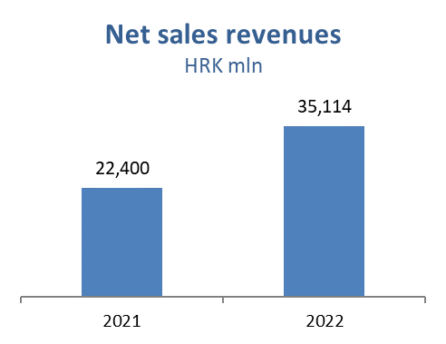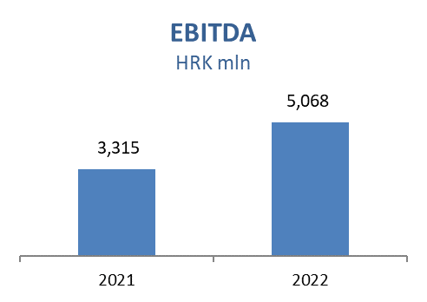
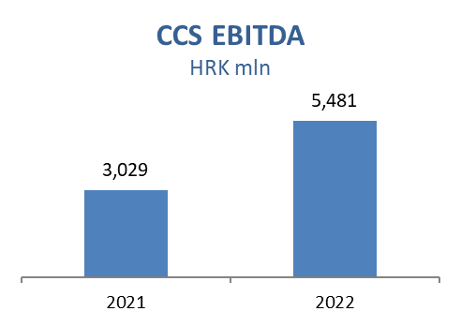
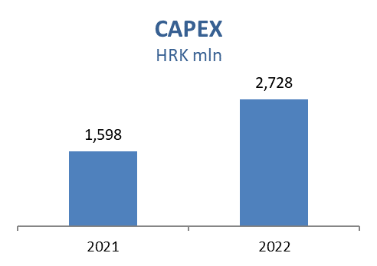

Exploration and Production
Higher prices impacted sales revenues positively since the strong effect of gas price regulation is visible only in Q4 2022. Revenues are higher by HRK 2,605 million, overall gas sales revenue added HRK 1,670 million positive effect, while 43% higher Brent price brought an additional almost HRK 0.8 billion crude oil and condensate sales revenues with other products positive impact on revenues in the amount of HRK 155 million.

The total production decreased by only 4%, compared to 8% decrease 2021 vs. 2020, which is strong result considering the maturity of INA’s oil and gas fields. This is mainly impact of an intensive investment campaign - successfully performed actions in the scope of Production optimization project, and positive effect of putting into production two new offshore wells (Ika B & Marica D), which almost offset natural decline and higher water cut on major gas fields on Deep Podravina area. International crude oil production - natural decline and lower well performance at all concessions in Egypt.

CAPEX level is higher mainly as a result of Croatia offshore drilling campaign and onshore development activities. Main activities during 2022 were related to:

Croatia Exploration:
  - Area Drava-03: Permitting and documentation preparation for drilling finished
  - Area North-West Croatia-01: Attribute analysis, geochronological study and economic evaluation finished
Croatia Development offshore:
  - Ika B-1 R and Marica D Dir well production started, authority technical inspection finished and use permit obtained
  - Drilling and well testing of wells Ilena-2, Ida D-1 ver, Ira-1 dir and Ida D-2 ver finished, economic evaluation underway
Croatia Development onshore:
  - In total 62 workovers were performed
Egypt:
  - East Damanhur: ED-2X exploration well was drilled as gas discovery
  - Egypt, North Bahariya concession: 9 development wells drilled

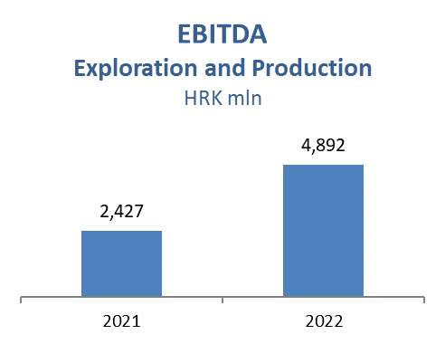
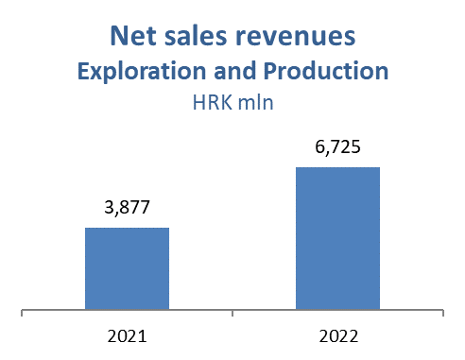

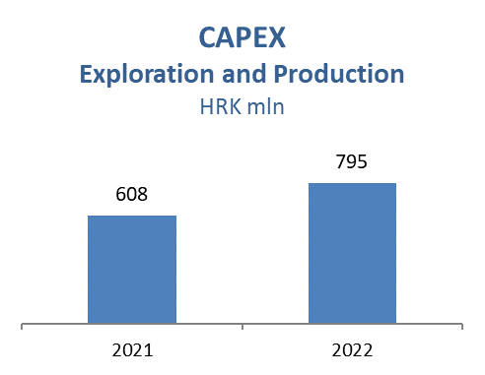

Refining and Marketing, including Consumer Services and Retail
Rijeka Refinery start-up was planned and executed at the end of March. Favourable macro environment supported profitable operation on maximum capacity in the peak summer months, mitigating risk of lower product availability on global market driven by Russian-Ukrainian crisis. Market was supplied from import from sea in Nov-Dec 2022 due to Rijeka Refinery Upgrade Project brownfield projects activities execution.

Trading activities were mainly focused on competitive crude sourcing, safe and timely product sales and supply, own consumption optimization and inventory risk management. In the challenging environment on the market INA stood out as a reliable supplier for all products, especially blue diesel.

INA maintained the strong market position on core markets, with both commercial and retail margins under pressure due to price regulations throughout 2022. Total Retail sales volumes amounted to 1,173 kt in 2022 which is 11% above 2021, with significant contribution coming from Croatian (+116 kt) market as a result of lifted COVID restrictions and excellent tourist consumption. Non-fuel margin increased 18% reflecting continuous expansion in consumer goods, increasing number of Fresh Corners and improved sales activities. INA Loyalty program in Croatia surpassed 450 thousand registered members.

Lower Clean CCS EBITDA was primarily driven by regulated prices of motor fuels and natural gas in Croatia together with downward fuel market price trends in H2 2022, which was to the great extent mitigated by strong refining margins, especially in Q2 period, and stable commercial performance.

Refining and Marketing CAPEX amounted to HRK 1,6 billion:

  - Rijeka Refinery Upgrade Project – The Project achieved 70% completion in overall, with mechanical completion expected in H1 2024. The engineering and procurement reached above 99% with all of the designs completed. Construction reached 52% including the heavy lifting of key equipment like Coke Drums and Fractionator for the Residue Upgrade Unit, performing most of the civil works on the maritime part of the Port and successfully passing test activities for the newly constructed high-voltage powerline and substations
  - CDU energy efficiency upgrade project – Main design completed in September 2022 and building permit issued in December 2022. All contracts for long-lead items signed. The first part of the civil works as well as major overhaul of the existing pumps is currently underway during Rijeka Refinery shutdown
  - Replacement of condensing turbines with electric drives – Detail design reached 90% completeness. Preparatory work started

Consumer Services and Retail capital investments amounted to HRK 142 million in 2022 with focus on service station modernization and continued roll-out of Fresh Corner concept, which is present at 137 service stations (out of which 101 in Croatia). Two new service stations opened in Croatia and Montenegro reaching 506 service stations on group level.

